WMS Transfer Guide
- Open your order in MES
( Example )
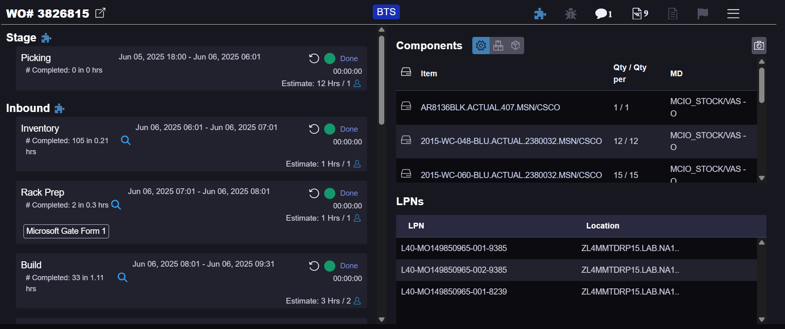
- The Material you’re transferring are going to be on your L40’s and are located here
( Example )
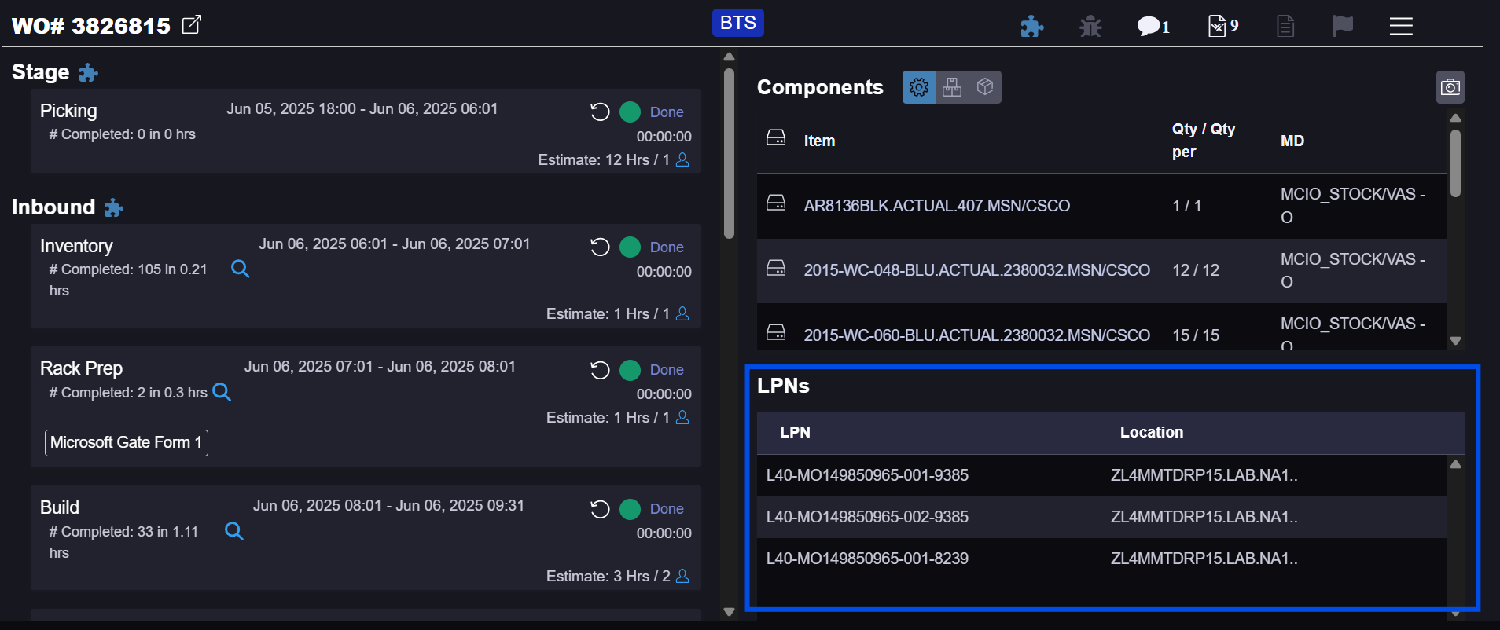

* ADVISE – if you notice anything other than DRP in your Locations Tab, grab an Admin before transfer *

- Open WMS / Secure CRT
Log into * XXWMS Warehouse User - N.A. *
You should now be on this page of WMS
( Example )
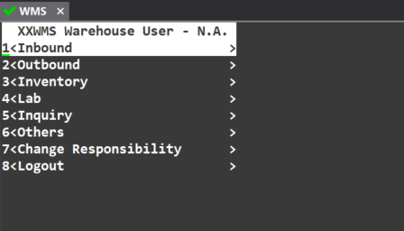
- Go to ( Inventory )
- Go to ( Transfers )
- Go to ( Subinventory Transfer )
- WMS should now prompt you with choosing an ORG Code
Type in ( 40 )
- WMS should now prompt you with choosing a Printer
Type in ( aa-000 )
- You should now be on this screen
( Example )
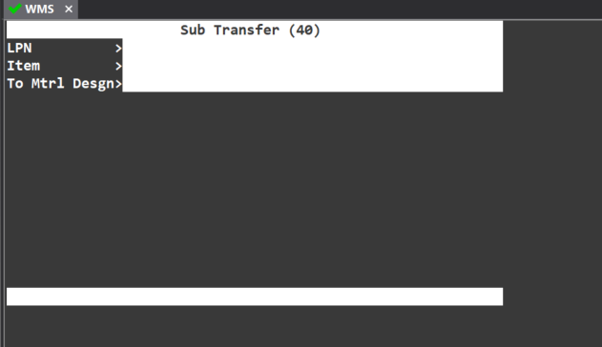
- Inside this LPN section you are going to put all the LPNs from you order into here
( To find the LPNs from your order scroll to the top of this guide and it will show you where to find them )

- Copy and Paste your LPNs one by one into the LPN section like so
( Example )
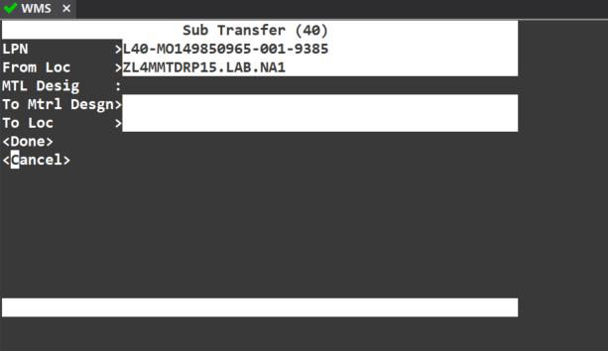
* Don’t worry about ( From Location ) as its just showing you where its being moved from *
- Now you should be under ( To Loc ) and this is the location your going to Scan or get from the Floor of where your moving your material too
Punch in your location then hit Done and do this for every L40 that is on the order
Once done with all L40’s then it should reflect on MES of where they were being transferred too
If you have any questions please don’t hesitate to ask the Admin Team

This instruction was made by Benjamin Cullum

